RAJESH KUMAR SINGH
Shatabdi Rail Vihar, Sector – 62, NOIDA, Uttar Pradesh - 201307
Mobile No: +91 9868090374 / Email: rajesh.rathore80@gmail.com
LinkedIn Profile: https://www.linkedin.com/in/rajesh-kumar-singh-5906b618/
--------------------------------------------------------------------------------------------------------------------------------
A dynamic and seasoned HR professional having business acumen, commercial focused, results driven and has the expertise to partner with all the stakeholders to drive profitable business.

Earned an MBA specializing in Human Resources and also hold Bachelor of Commerce and Post Graduate Diploma in Labour and Administrative Laws. A certified PPA Practitioner (Thomas International’s Personal Profile Analysis).

Has over 14 years of experience in different aspects of Human Resources Management and has got multi-faceted exposure like Corporate HR, Factory HR, HR Business Partner and Strategic HR at different levels in diversified industries viz. FMCG, Fashion & Apparel, EPC and Railroad Manufacture / Rolling Stock (Transportation).

Has got hands-on-experience of setting-up of an HR Function, Policy Formulation, Providing Strategic HR Support to Business Unit Head, Organization Re-structuring, Finalization of Compensation and Benefits for International Projects, Manpower Budgeting & Wage Cost Analysis, Performance Management System, Talent Acquisition, Rewards & Recognition, HR Analytics, Work Level/Grading System Implementation and HR Operations.

Has an experience in dealing with different nationalities and has handled multi-culture organizations. Rajesh has handled operations and traveled to Kenya, Thailand, Nepal, Ethiopia, South Africa, Malaysia, Hong Kong, Zambia, Sierra Leone and United Kingdom.

Expertise: Strategic HR, Policy Formulation, HR Analytics, Organization Re-structuring and C&B (Intl’)
--------------------------------------------------------------------------------------------------------------------------------
EMPLOYMENT CHRONICLE
- Progress Rail, A Caterpillar Company
Country HR Manager (India & South Africa)
October 2017 till date
Role – Country Head HR

- TATA Projects Limited (TATA Group)
Assistant General Manager – HR
April 2007 to till date
Role – Senior HR Business Partner

- Ray-Ban Sun Optics India Limited (Luxottica Group, Italy)
Assistant Officer – HR
May 2006 - April 2007
Role – Factory HR

- VRS Foods Limited (Paras Dairy)
Jr. Executive – HR
January 2005 - May 2006
Role – Corporate HR
-------------------------------------------------------------------------------------------------------------------------------

PROFESSIONAL EXPERIENCE
Progress Rail Innovations Private Limited, A Caterpillar Company
October 2017 to till date
Country HR Manager (India & South Africa)
Role – Country Head HR

1.

Responsible for entire gamut of Human Resources, Administration, Facility Management and Statutory Compliance functions of India Operations. Managing five facilities/offices in India including an Assembly Unit at NOIDA, Uttar Pradesh and a Production Unit at Raipur, Chhattisgarh. Having dotted line reporting to Managing Director (India).

Also responsible for managing HR Operations in South Africa as Country HR Manager for which I coordinate with Regional Director (Sub Saharan Africa Region).

Straight line reporting for operations of both the countries is to Director International HR based out of US.

Other Key Portfolios / Authorities in India:

- Trustee in Gratuity Fund Trust.
- Authorized Signatory for EPFO matters.
- Facility Manager for India Operations.
- Member of the Corporate Leadership Team (CLT), India.

Progress Rail India is owned by Caterpillar Inc. USA. Progress Rail (Rail Division of Caterpillar and a manufacturer of EMD brand Locomotive and OEM parts) was a part of General Motors Corporation, USA till 2005 and was formerly known as Electro-Motive Diesel. It builds, maintains, and services a range of locomotives, including freight, passenger, mining, and switching locomotives for customers worldwide. It also offers diesel power engines for marine propulsion, offshore and land based oil well drilling rigs and stationery power generation.

Progress Rail is a leader in some of the products in Rail Industry and competes with GE Transportation, Bombardier Transportation, Siemens Mobility, Alstom Transportation, Hitachi, Toshiba and China Rail Road Corporation.
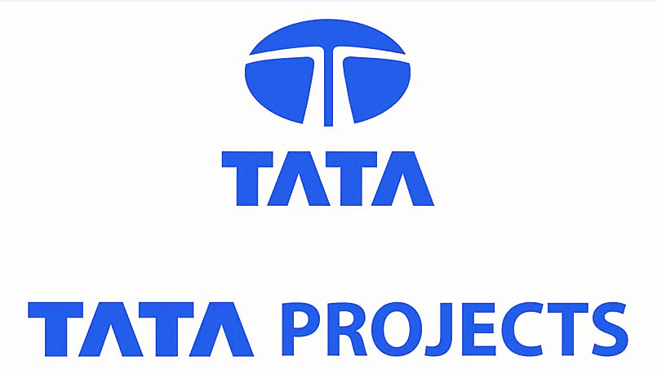

TATA PROJECTS LIMITED (TATA Group)
April 2007 to September 2017
Assistant General Manager – Human Resources
Role: Senior HR Business Partner

2.

I was responsible for entire gamut of HR of Power Transmission & Distribution Business Unit of the Company including HR Operations in Ethiopia, Kenya, Sierra Leone, Thailand, Nepal and Zambia. I was involved in Talent Acquisition, HR Analytics, Manpower Planning & Budgeting, HR Operations, PMS and Policy Formulation with additional responsibility of Statutory Compliance and Administration function of the BU.

I managed the headcount of 1500 including Third Party Staff with the support of 5 team members.

I used to administratively report to Business Unit Head and functionally to Head – HR.

Key Achievements / Highlights of the Career in TATA Projects:

- I played an important role in achieving the BU’s Turnover from Rs. 350 Cr. in FY 2007-08 to Rs. 2300 Cr. in the FY 2016-17.

- I was instrumental in establishing Distribution and Substation Line of Businesses from scratch and facilitated Business Unit Head in generating revenue of 600 Cr. (approx.) from these two verticals in the FY 2016-17.

- I was a core team member to finalize Compensation & Benefits for Overseas Projects (salary and tax computation on overseas earnings, proposal of overseas allowances, preparation of note for approval, etc.) and to draft policies based on the inputs received from Corporate HR and Projects Team (drafted Incentive Policy, R&R Policy, Hardship Allowance, Amendment to Leaves Entitlement Policy, Policy for Entitlements & Benefits for Overseas Projects, etc.

- Visited Kenya, Nepal, Thailand and Ethiopia for market survey, meeting with legal consultants, finalization of recruitment agencies for local hires, walk-in interviews, etc.

- Promoted five times in a span of ten years and rose from the level of Officer – HR to Assistant General Manager – HR and led the HR functions of one of the biggest Business Unit of TATA Projects.



Ray-Ban Sun Optics India Limited (Luxottica Group, Italy)
May 2006 to April 2007
Assistant Officer – Human Resources
Role: IR Officer / Factory HR

3.

I was posted at the manufacturing unit of Ray-Ban India at Bhiwadi, Rajasthan and used to assist IR Manager in Statutory Compliance.

VRS Foods Limited (Paras Dairy)
January 2005 to May 2006
Junior Executive – Human Resources
Role: Corporate HR



4.
4.

I was posted at the Corporate Office in Delhi and used to assist HR Manager in Talent Acquisition, Training & Development and Performance Management System.
--------------------------------------------------------------------------------------------------------------------------------
EDUCATION

2003-2005 MBA – HR from Guru Jambheshwar University, Hissar (Haryana)
1997-2000 B. Com. from Ram Lal Anand College, South Campus, Delhi University
2009 PG Diploma in Labour and Administrative Laws from Madurai Kamaraj University (Correspondence Course)
2000 Advance Diploma in Computer Software Technology from ET&T Corporation Ltd.
(A Govt. of India Enterprises)
--------------------------------------------------------------------------------------------------------------------------------
INTERNATIONAL EXPOSURE

- Visited Kenya for market survey, meeting with the consultants and establishment of office.
- Visited Thailand for Site Visit, facilitated scheduled interviews for local hires and meeting with Consultant.
- Visited Nepal for Walk-in Interview for Technical positions.
- Visited United Kingdom for understanding of new line of business
- Countries Visited: Kenya, Malaysia, Thailand, Nepal, Hong Kong, Macau, South Africa and United Kingdom.

CERTIFICATION (S)

- Certified PPA Practitioner (Thomas International’s Personal Profile Analysis)
--------------------------------------------------------------------------------------------------------------------------------

PERSONAL DETAILS

- Father’s Name : Capt. Ramlal Rathore (Retired)
- Languages Known : English and Hindi
- Date of Birth : January 4, 1980
- Marital Status : Married
--------------------------------------------------------------------------------------------------------------------------------
BUNCH OF INFORMATION
Personal | Professional
Passionate Bullet Rider | Team Size – 5
Passionate Safari Driver | Current CTC – 40.26 lacs per annum
Love Travelling | Notice Period – 3 Months
Disciplined, Focused, Extrovert | Current Location – NOIDA (Delhi/NCR)

REFERENCES

- Mr. Arun Joshi (Ex-Reporting Manager), CHRO, Yakult Danone India Private Limited

- Mr. Prashant Jha (Friend in HR fraternity), Head – HR, Toshiba India Private Limited

- Mr. Ajay Prasad (Mentor in HR), VP – HR, Unison Insurance Broking Services Pvt. Limited

- Mr. D Nagendra Prasad (Ex-Reporting Manager), Director – HR, Apeejay Stya Group

- Mr. A Ratna Sekhar (Ex-Reporting Manager), Director – HR, Balmer Lawrie & Co. Ltd, Kolkata

- Mr. Balakrishnan Chidambaram (Current Reporting Manager), MD (India), Progress Rail, A Caterpillar Company

- Mr. Vivek Gautam (Ex-dotted line Reporting Manager), COO, TATA Projects Limited
--------------------------------------------------------------------------------------------------------------------------------

Rajesh Kumar Singh

